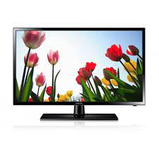

Samsung J4303

* Sound Mode: Wallmount
* USB Play: Yes
* Screen Size: 32 Inch
* AC100-240V 50/60Hz
* **Rs. 35,999**